User Manual of *Snap&Go*

Table of Contents

Welcome Page 2

Signing up: 2

Logging in: 3

Main Menu 4

Changing the voice: 5

Creating a new document: 6

Creating a new document from a new picture: 6

Creating a new document from an existing picture: 7

Working Area 8

Saving your document 8

Adding text 9

Using text to speech 9

Sending your document 10

Administrative Web Application of Snap&Go 11

Add User: 11

Delete User: 12

Files: 13

Helpful Contacts 14

Contributions 14

# **Welcome Page**

On this page, you may either log in as a returning user or sign up and create a new account.

* Press on the *Sign Up* (A close up of a logo

  Description automatically generated) icon if you are a new member.
* A screenshot of a cell phone

  Description automatically generatedPress on the *Log In* (A close up of a logo

  Description automatically generated) icon if you are a returning member.

## **Signing Up:**

1. A screenshot of a cell phone

   Description automatically generatedA screenshot of a cell phone

   Description automatically generatedType your full name.
2. Type the email address you want to use to create your *Snap&Go* account.
3. Select your role: “student” or “teacher”
4. Press on *Next* (A picture containing table

   Description automatically generated).
5. Type in your chosen password in the space provided.
6. Re-type your chosen password in the space provided.
7. Press on Create Account (A screenshot of a cell phone

   Description automatically generated).

## **A screenshot of a cell phone Description automatically generatedLogging In:**

1. Type your email address used with the account in the indicated space.
2. Type your password in the indicated space.

* if this is the first time accessing your account and it was created by Summit School for you, your password is: “summit”.

1. Press on *Log in* (A close up of a logo

   Description automatically generated).

* If the page below appears, verify that you have the correct email and password associated with an existing account. You can then try again.
* Be mindful of the capital letters in your password (if any).

# **Main Menu**

This is the page where you can see all the documents that you have created up to date. Your possible actions are the following:

* Create a new document by pressing on *Create* (A close up of a piece of paper

  Description automatically generated) in the top left corner.
* Access the settings by pressing on *Settings* (A close up of a wheel

  Description automatically generated) in the top right corner.
* Open an existing document in the Working Area by pressing on the document of interest (e.g.A screenshot of a cell phone

  Description automatically generated ).

**Settings Menu**

On this page, you can do the following:

* Return to the Main Menu by pressing on the *Back Arrow* (A close up of a sign

  Description automatically generated) in the top left corner.
* Log out from your account by pressing on *Logout* (A screenshot of a cell phone

  Description automatically generated).
* Change the voice that is used in the text-to-speech option by pressing on *Change Voice* (A picture containing table

  Description automatically generated).

## 

## **Changing the Voice:**

You will be taken to the Apple Settings Menu. From there, you can modify the voice settings to your desired preferences. These modifications will be applied to the text-to-speech function directly on *Snap&Go*.

# **Creating a New Document:**

After selecting this function, you will have 2 options to choose from:

* Create a new document from a new picture.
* Create a new document with an existing picture from your iPad’s Photo Gallery.

## **Creating a New Document with a New Picture:**

This function will activate your camera, allowing you to take a picture of a worksheet. This new picture will then be transferred to the app allowing you to work freely on it.

1. Take a picture of the document (e.g. worksheet) you want to be copied to *Snap&Go*.
2. You will then be taken to a Preview Page where you will be able to see your picture be converted to a PDF file with machine-readable text data through OCR (optical character recognition). From there, once the converting is done, you can do one of the following:
   1. A screenshot of a cell phone

      Description automatically generatedIf you are not satisfied with the picture you have taken, you can return to the Main Menu by pressing on the *Back Arrow* (A close up of a sign

      Description automatically generated), from where you will be able to re-do the process of step 1 and 2 written above.

*IMPORTANT* If you choose that option, the PDF file you see on the Preview Page will not be saved.

* 1. If you are satisfied with the picture you have taken, proceed to the Working Area by pressing on the *Forward Arrow* (A close up of a sign

     Description automatically generated). This PDF file will be saved.

## **Creating a New Document with an Existing Picture:**

This function will take you to your iPad’s gallery, allowing you to take select to picture of a worksheet. This picture will then be transferred to the app allowing you to work freely on it.

You will be taken to your iPad’s gallery, from where you will be able to.

1. Select the picture you want to be copied into *Snap&Go*.
2. You will then be taken to a Preview Page where you will be able to see your picture be converted to a PDF file with machine-readable text data through OCR (optical character recognition). From there, once the converting is done, you can do one of the following:
   1. A screenshot of a cell phone

      Description automatically generatedIf you are not satisfied with the picture you have taken, you can return to the Main Menu by pressing on the *Back Arrow* (A close up of a sign

      Description automatically generated), from where you will be able to re-do the process of step 1 and 2 written above.

*IMPORTANT* If you choose that option, the PDF file you see on the Preview Page will not be saved.

* 1. If you are satisfied with the picture you have taken, proceed to the Working Area by pressing on the *Forward Arrow* (A close up of a sign

     Description automatically generated). This PDF file will be saved.

# **Working Area**

This is the page where you can work on your documents. Your available actions are the following:

* Return to the Main Menu by pressing on *Back Arrow* (A close up of a sign

  Description automatically generated).
* Save your document by pressing on *Save* (A close up of a screen

  Description automatically generated).
* Add text to your document by pressing on *Add Text* (A close up of a piece of paper

  Description automatically generated).
* Hear written text on your document being read out loud to you by pressing on *Text to Speech* (A picture containing table, sitting, pair

  Description automatically generated).
* A screenshot of a cell phone

  Description automatically generatedSend your document to someone by email by pressing on *Send document* (A picture containing white, sitting, table, cake

  Description automatically generated).

**Saving your Document:**

To save the modifications and progress on your document, press on Save

). A spinning wheel will appear on the screen to indicate saving process. Once it disappears, it means that the modifications you brought to your document were successfully saved.

), do not worry, your modifications will still be saved.

*IMPORTANT* However, your modifications will not be saved if you quit *Snap&Go* from the Working Area without saving.

**Adding Text:**

1. Press on *Add Text* (A close up of a piece of paper

   Description automatically generated).
2. A text box will appear on your document, in which you can type what you want.
3. Once you are done typing, to exit text box, press somewhere outside of the text box on your document.

You can move your text box by pressing on it again and dragging it across the page.

You can change the size of your text box by pressing on any of its corners and dragging it to fit the desired size.

You can modify the text you previously wrote in a text box by pressing directly on the text in the text box.

**Using Text to Speech:**

1. Press on *Text to Speech* (A picture containing table, sitting, pair

   Description automatically generated).
2. You will have 2 options:
   1. *Automatic Text to Speech* (A picture containing monitor, car, outdoor, clock

      Description automatically generated) will make the iPad read out loud all the text that is found on the document, from top left to bottom right.
      1. Press on *Automatic Text to Speech* (A picture containing monitor, car, outdoor, clock

         Description automatically generated).
      2. The iPad will start to read all the text on the document.
   2. *Selecting Text to Speech* (A close up of a device

      Description automatically generated) will allow you to select the area you want the iPad to read from, from top left to bottom right.
      1. A screenshot of a cell phone

         Description automatically generatedPress on *Selecting Text to Speech* (A close up of a device

         Description automatically generated).
      2. Select the area you want to be read out loud by making a rectangle through dragging your finger across the screen from one corner to its opposite corner.
      3. The iPad will start to read all the text on the document within the rectangle you just drew.

For now, whichever version of the tool you decide to use, you cannot stop the iPad from reading the text you wanted until it completely finishes.

**Sending your document:**

1. Press on *Send document* (A picture containing white, sitting, table, cake

   Description automatically generated).
2. The window of your email service provider will open.
   1. The subject of your message will automatically be generated.
   2. The version of the PDF file you see (whether you pressed *Save* [A close up of a screen

      Description automatically generated] before or not) will be attached to the email.
   3. Feel free to modify the subject and/or content of your email!
3. Type in the email of the person you want to send your document to in the space provided (next to *To:*).
4. Press on *Send* (A picture containing animal

   Description automatically generated).

# **Administrative Web Application of *Snap&Go***

Link: <http://summit-web.herokuapp.com/?fbclid=IwAR2-MrWM1m19PJRjXCNdXO56C2_4KnYXxFhgOkA5jk2Rf2zB0hUmGXG1QhQ#/>

This website is an extension of *Snap&Go.* It was created with the purpose of allowing a person (e.g. an employee of Summit School) to create and delete members from a webpage, and to delete files from the database. The development team is still in the process of making the website protected by a password.

Instructions on how to use this extension can be found directly on the website, in the Help Page. Below is a copy of these instructions:

## **Add User:**

To create a new user, enter the following information in the appropriate bar:

* User’s name - as will be displayed on Snap&Go app
* User’s email - will be associated with the new account
* User's role - enter 1 for student, 2 for teacher

For every new user added to Snap&Go from this website, the default password is “summit”. This password can later be changed by the new user on Snap&Go app.

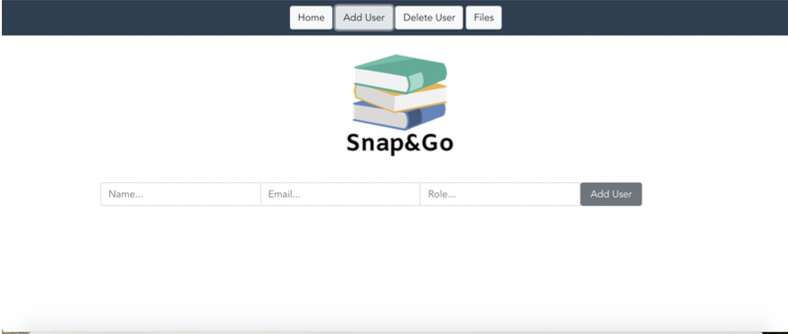

## **Delete User:**

* (Optional) The search bar allows you to track down the ID of users you want to delete from the database using their name or email. The search results will be shown in the user list below.
* Enter the ID of the user you want to delete from the database.
* Hit the “Delete” button.
* (Optional) Hit “Refresh” to update the user list visible below. Although the change will have taken place, it will not show in the user list until “Refresh” has been hit.

Instead of using the search option, you can also scroll up and down the user list to locate the users you want to remove from the database to find their IDs.

You can remove only 1 user at a time.

**\*Note: Once you delete a user, all files created by that user will be erased from the database.**

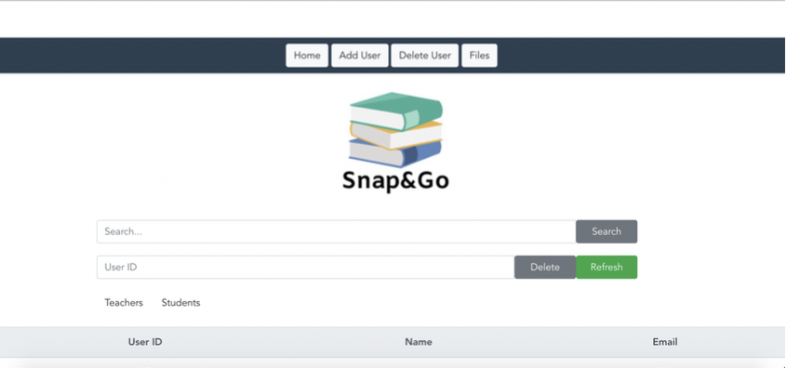

## **Files:**

The search bar allows you to locate the files created by a user. You can use either the user’s name, ID or email to do this search. The search results will be shown in the file list below, which would otherwise show all the files presently on the database.

The tool available here to delete many files at the same time functions by DATE CREATED. In other words, this tool allows you to free up storage in Snap&Go app’s database. Thus, all files created ON the date you enter AND the ones PRIOR to it will be erased. For this tool to work, you need to input the date as follows: "YYYY-MM-DD" (hyphens included).

To see the updated version of the file list, hit “Refresh”. Although changes will have taken place immediately after having hit “Delete all”, it will not show in the file list until “Refresh” has been hit.

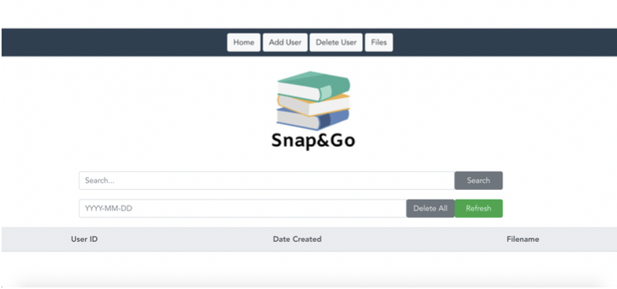

# **Helpful Contacts**

For further questions about the functioning *Snap&Go*, you can contact any of the members of the developing team below:

Engineering students:

* Mary Jane Tucker: [mary.tucker@mail.mcgill.ca](mailto:mary.tucker@mail.mcgill.ca)
* Samantha Cattani: [samantha.cattani@mail.mcgill.ca](mailto:samantha.cattani@mail.mcgill.ca)
* Donya Hojabr: [donya.hojabr@mail.mcgill.ca](mailto:donya.hojabr@mail.mcgill.ca)

Occupational therapy student:

* Maï-Li Gravel: [mai-li.gravel@mail.mcgill.ca](mailto:mai-li.gravel@mail.mcgill.ca)

# **Contributions**

***Snap&Go* development team:**

Mary Jane Tucker

Samantha Cattani

Donya Hojabr

Maï-Li Gravel

***Snap&Go* collaborators:**

Summit School team